3rd Iterations of website

**Front page changes**

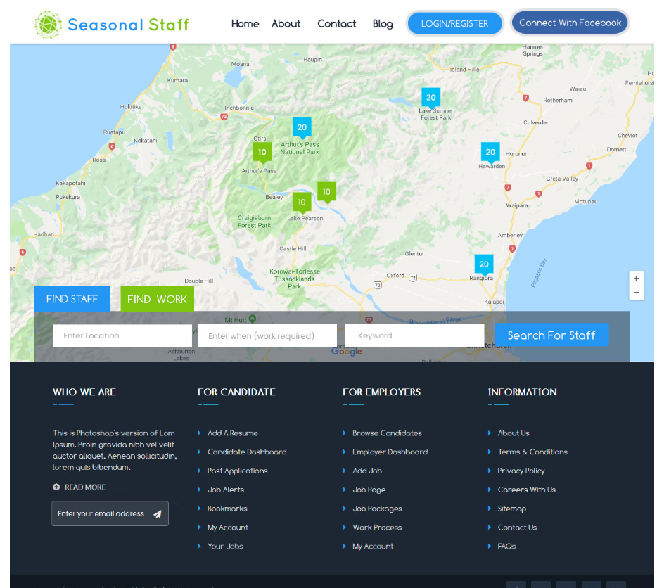

Can these below buttons be rounded to match the login an connect with facebook buttons please

Can you also change the “login / Register” button to “login / Join Now” putting a space in between each word.

For the purposes of any Confusion…. Join Now…. Is the same as Register or sign up.

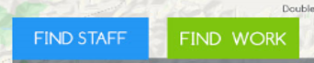

Find work page. (below) is it possible to have a heading underneath the map (on all pages please ) to clearly identify what

Page they are currently on. I have sometimes found it a bit confusing to identify which page we are on in the flow of things.

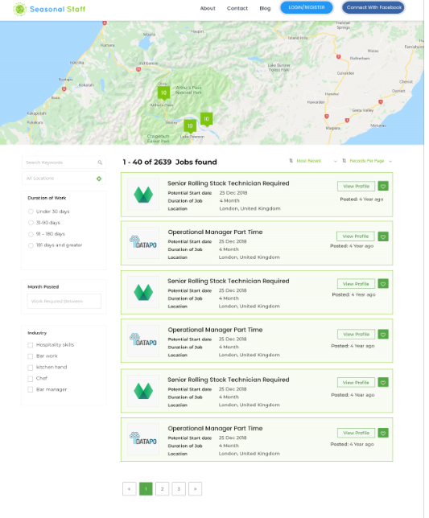

**Job search results page changes**

Can the logo be the same size on all of the pages as is on the front page.



Can we please have a heading directly underneath the map of each page, (and all pages) this will make it easier for

People to know what page they are currently on.

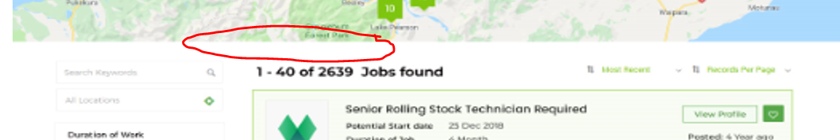

Don’t see the relevance of having this on the page… this would be a useful feature for us being admin but feel that it is

not needed as search feature

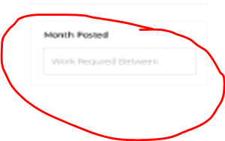

Where I have marked below can this be where an employers and employees rating be placed

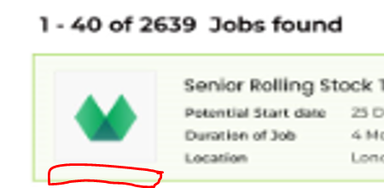

Could the sizes of these job boxes be slightly bigger? As I would like to have the following headings added to the preview box. “Additional benefits

“the first few will be listed (but show that there were more not shown) “approx. hours per week” this would list the hours e.g. 32 hours per week.

“Intensity of work”, this would show as …light, average,above average. “Hourly rate” this would show hourly rate e.g. $17.50 (+ 8% holiday pay) or negotiable.

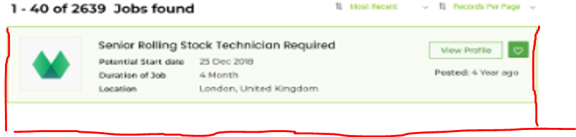

Please remove Industry and replace with “other benefits” as a heading

This would then include,

*Accommodation Provided,

*Onsite parking with power

*Onsite parking without power

*Toilet and show facilities available

*Laundry available.

*Kitchen facilities available

*Wi-Fi available

*animal friendly

*other benefits

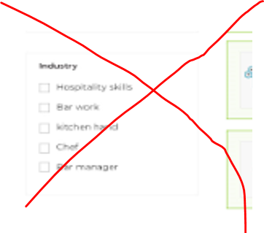

Duration of Job… could this be shown in number of days please instead of months. This would align with the search feature we have.

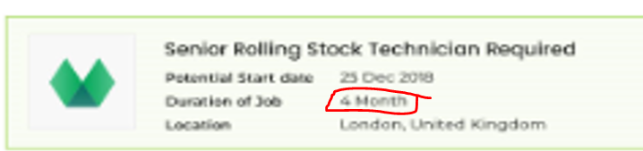

-------------------------------------------------------------------------------------------------------------------------------------------------------------------------------------------------------

**Staff Search results page changes**

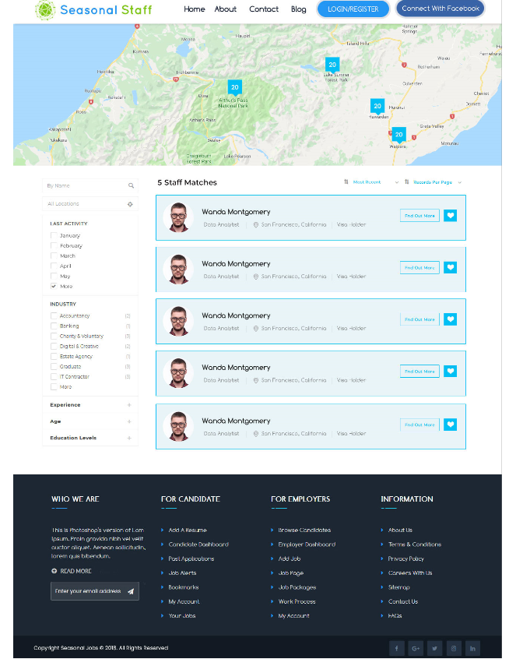

As mentioned before can we please have a clear heading so that the user clearly knows what page

they are on and don’t get confused. E.g. “Find Staff” Search results or something like that.

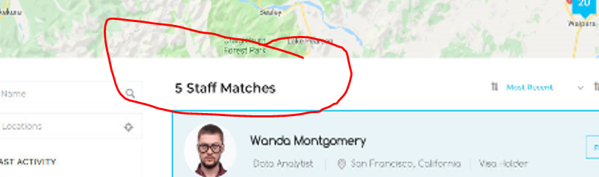

Below could this please be shown as a person’s user name (if being viewed by a unregistered user) once the user is registered

Then the person’s details will be shown. (This is for privacy reasons)

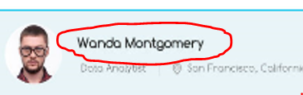

Can we please make the profile box a bit bigger so we can show a bit more information?

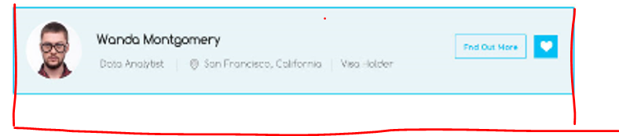

Would like to show the following in the preview.

Current location

Eligibility to work in New Zealand (would be a yes or no)

Visa status (would show working visa, New Resident, Visa currently pending etc.)

Level of English, (would, show as basic, Good, excellent)

Key skills. (This would show the top 3-4 (and then indicate that there are more)

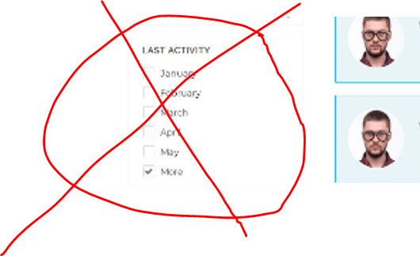 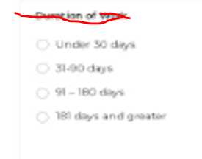

Could you please change the last activity to match the Duration of work format?

E.g. In the last 30 days

31-90 days

91- 180 days

181 days and greater

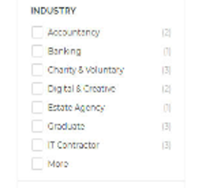

**********We will provide a list of Industries to you (Wayne to provide)

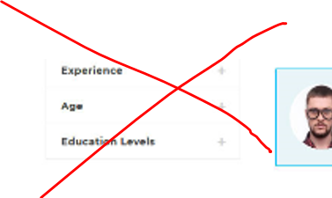

Please remove this section from the search as (in New Zealand this would be considered discrimination)

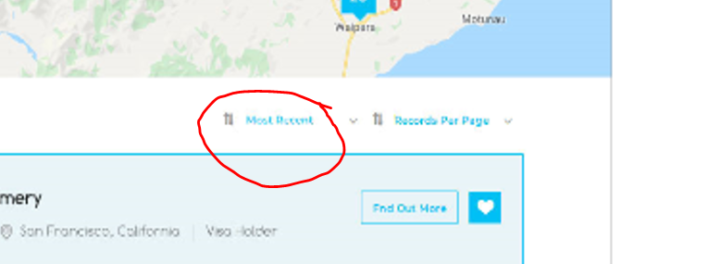

Is it possible to have one of the options to be by closest to the employer’s location? This would be

Most helpful.

**-----------------------------------------------------------------------------------------------------------------------------------**

**Job profile Page changes**

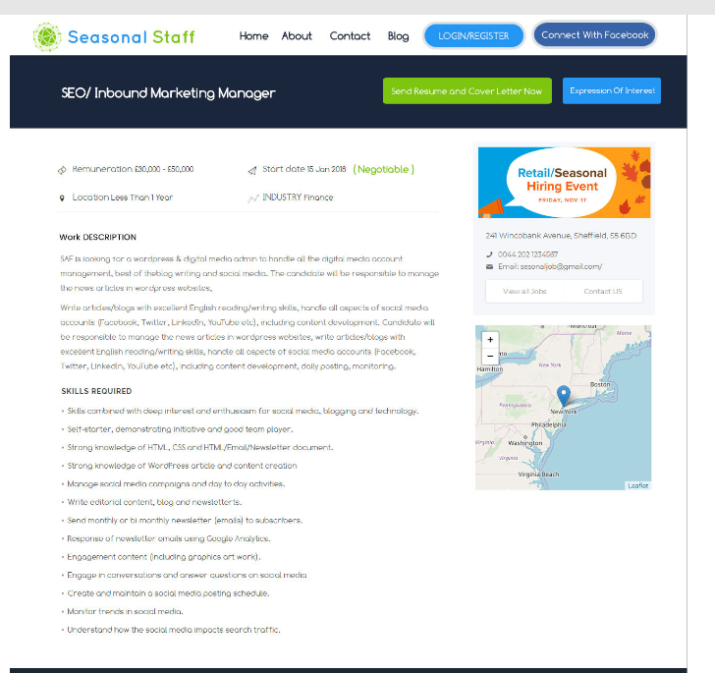

Please can you change the blue button to “ Yes I am interested”

And the Green button to say “ Send CV and Cover letter now”

Also when the employer puts the job up they choose if they want to received a full CV and Cover

Letter or receive “yes I am interested” which is a more casual way of applying for a job. I envisage

That this will happen by a ticking a box when the employer creates a job. If there is an option to add

A CV and cover letter when sending the “yes I am interested” that would be good. (but is optional)

I would prefer that both buttons are not shown at the same time.

Also if a person has not registered at this time, they would not be able to send a CV or say “yes I am interested” it would

Force them to the registration page.



Please remove the contact details, so that they are not visable

to non registered viewers.

I am happy that the view all jobs will

be shown, but would like the contact us button to force a non

registered user to the registation screen if they have not registered

If they are registered all the contact details will apear for the

Registered user.

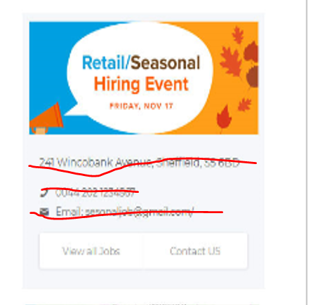

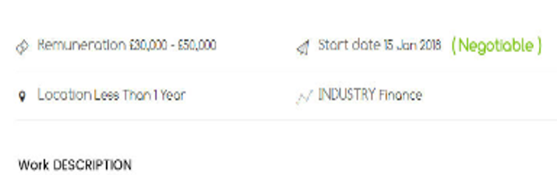

Could the order be the same as in the preivew on the find a job page…

Eg “potential start date” “location” this would only show the “city or town closest” not a physical location. “Duration of job” “hourly rate”

“Hours per week” “intensity of work” “Industry” and “Other Benefits” (this would show as a list and would be drawn from a list of which

the employer has selected from”This way the employee can see a lot of information given in an overview at the top of the Job advert, and not have to do a lot of reading.

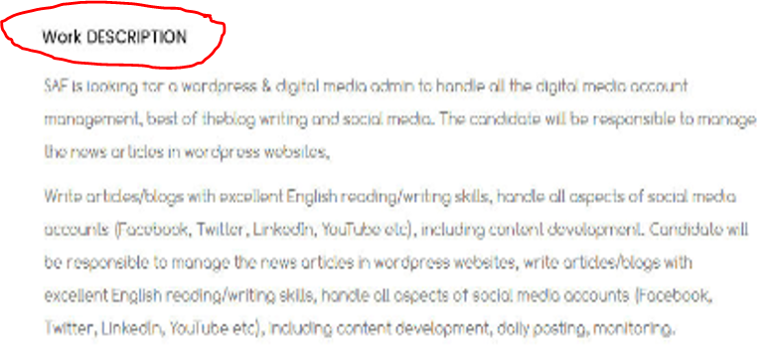

Please change this to “Description of Job” and the employer would be able to copy and paste or type these details in.

Please chage “Skills requred” to Skills and attributes required”

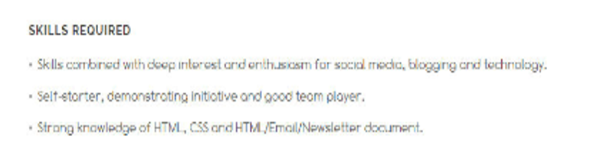

**-----------------------------------------------------------------------------------------------------------------------------------**

**Posting a Job page changes**

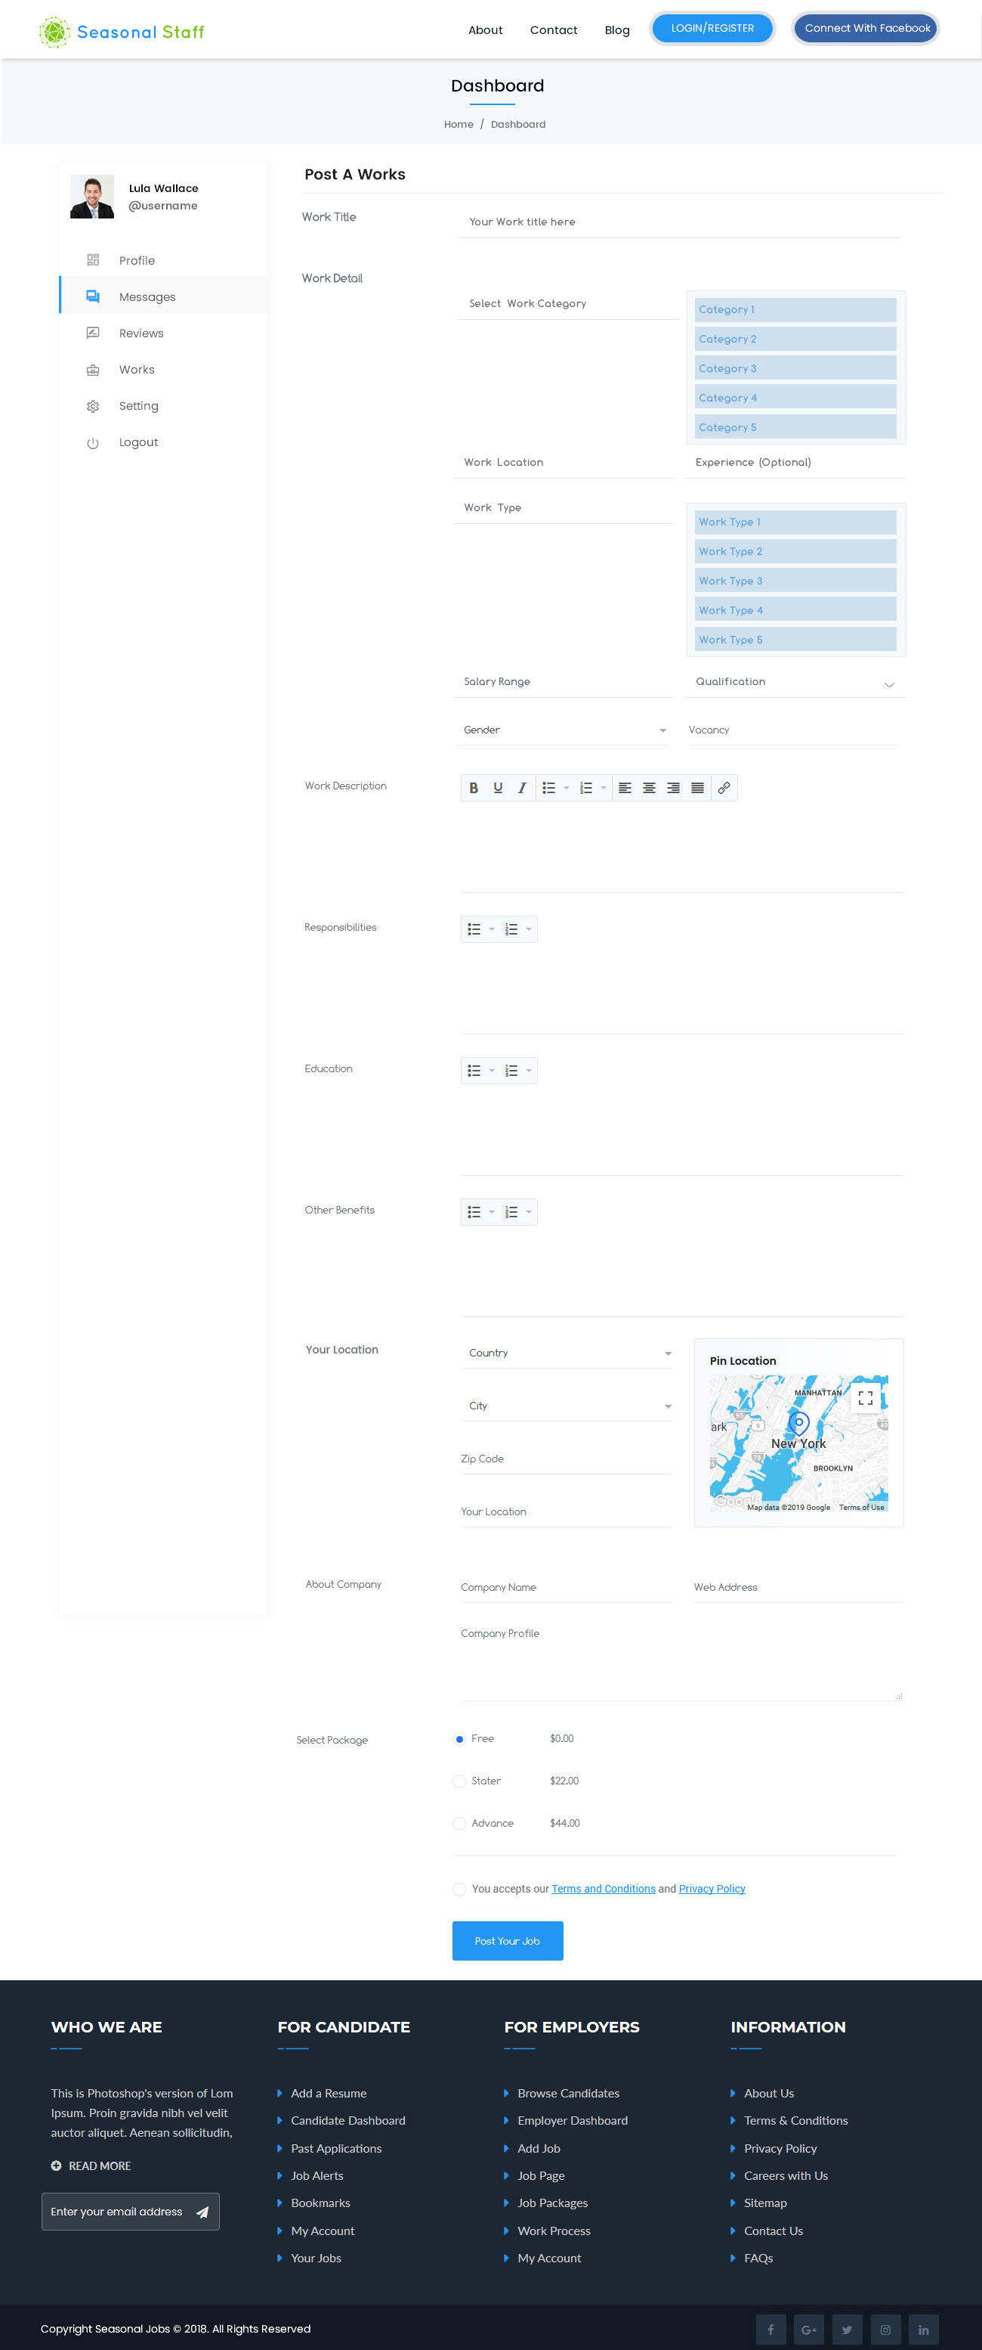

Could this be changed to “Employer Dashboard.”



Plese change the following “Post a works” to List a Job”, “works title” to “ Job Title”

Then list in this order

Job Title,

Industry (this would provide a drop down list that the employer would select from)

**Location of Job (eg town or city location) from google selection- (Please see notes on the location below)

Potenital start date (this would be a calendar they can select on or can type the date in)

Potential End date (This would be a calendar they can select on or can type the date in) (this would then calculate the duration of job.)

Aprox Hours per week (Employer could click a list to put in a number or select 0-10, 11-20, 21-30, 31- 40, 40+ or changeable)

Hourly rate. (Employers can put in a $ amount per hour) then tick a box to say includes or excludes 8% holiday pay, ) or put in by negotiation.

Intensity of work. (this would show a drop down selection where the employer could choose the following “light, average, above average”

Other benefits (I would like this to show as a check list that the employer could pre select, (see below)

Accommodation provided Onsite parking with Power Onsite parking no power

Kitchen facilities available Laundry facilities available Shower and toilet facilities available

Wi-Fi Animal friendly other (this would allow an option for the employer type in what the offer) (restrict this to 70 characters)

Description of Job – This would be an area that they can put in details about the job (limit to 500 Characters)

Skills required – this section would prompt the employer to list a skill (then add another Skill) so that they presented as

A list of bullet points. Add to a maximum of 15 skills. (Each box able to be free typed in to a maximum of 70 characters

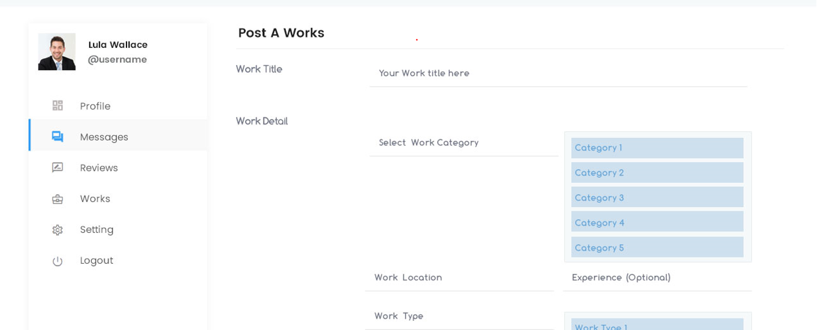

**Please remove all other boxes and refer to notes already on “Decription of work “ and “other benefits”**

**Location notes. (see notes below)**

**We think that one company might have several different locations, Eg Auckland, Wellington and Christchurch. we want to be able to charge each location a separate fee**

**, For use of website. (eg Single location business) or (Multiple location business)So we would like an option for a business to add a different location and if they did that**

**would they would be charged an additional fee. (I will expand more on this in the business registration Part of this.**

**About company – I envisage that this part of will be filled in when the business registered as a user (please remove from the job posting page)**

**Select package- We would like to keep this option to add this later to boost ads, or promote to certain audiences. (Please can you remove for the meantime, but it is**

**Some thing we would like to implement later)**

**Please keep the accept our terms and conditions and privacy policy.**

**Please add two extra buttons by “ post your job” these additional buttons would be “review your add” This would show what the advert would like like if it was posted”**

**And the other button would be “edit your job” This would allow the employer to Edit or remove the add.**

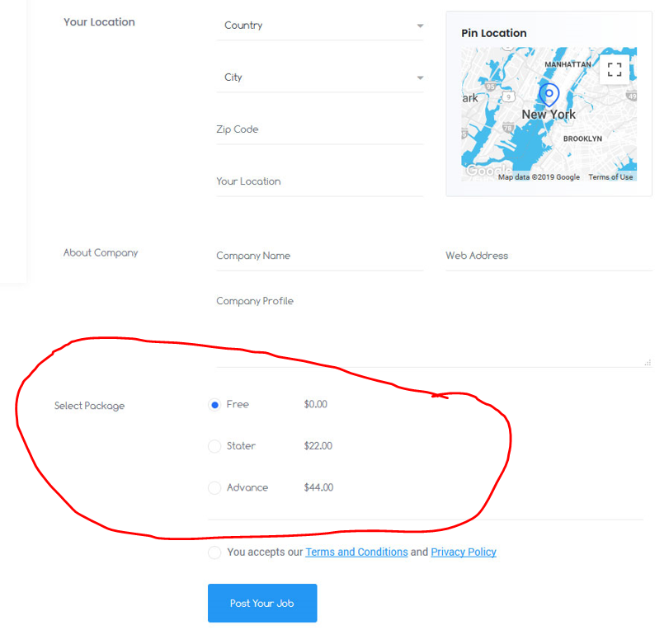

**Posting a job has shown that it is under messages. This needs to be under Works. (I will touch on renaming and reordering these a bit later) Please can you ensure**

**that for now creating, editing and posted ads show up in “works” not messages.**

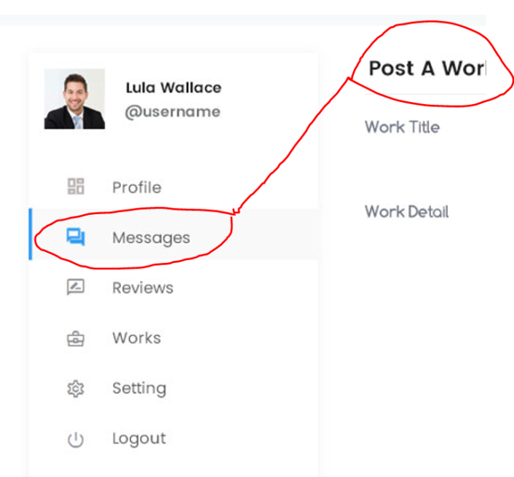

**Business user /profile / Dashboard page changes.**

Please change “basic info” to “Business info”

Change “Full name” to “Name of Account Manager” Change “email address” to ”Account Manager Email”

Change “Phone “ to “Account Manager phone” Change “Address” to “Business location” (using Google map to find this)

Change “industry experties” to “Industry” Change “About me” to “About our Business” I would like to this to be able to be

Linked to their job ads so that if an employee wanted to know more about the company (once they are registered) they could read this section.

I would like to have the ability for business to “ add locations” eg if they have an office in Auckland, wellington or Christchurch, They could add a

Additional contact and address, so they can put ads in for different locations.

Change passwords all good.

Please can you add a button beside “save changes” with a “edit Business profile” button.

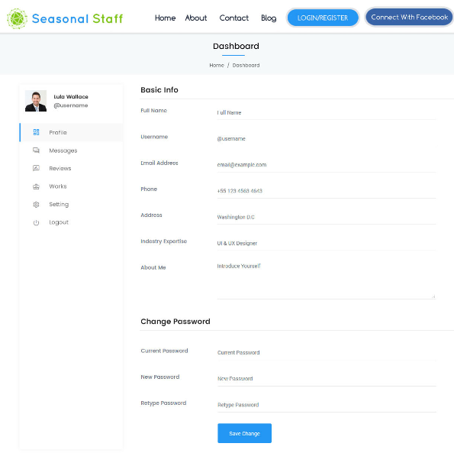

**------------------------------------------------------------------------------------------------------------------------**

**Sign up page reivew and changes**

Please change the Staff to “Blue “and the Employer to “Green

Please change the wording under staff to “ I want to find Seasonal or short term work”

Please change the wording under Employer to “ I want to Find Seasonal or Short term workers”

Please remove the categories section.

When they push the “Sign up button” they are asked to make a payment online banking or credit card.

Once they make the payment they can choose to

“Create a profile “ or “have a look around”

“Create a profile” will take them to either the business or employee profile page

If they apply for a job and have not created a profile, please can there be a prompt that remind them about

Creating a profile “

“have a look around” will allow will take them to the main page “

Please change “ Signup to your account” to “signup now” (please centre it in the middle”)

We also need to ensure that Employers cannot sign up as a worker and make contact with workers

Without having the right. Eg if the employer signed up as a worker and tried to make contact with a

Worker it would say “ you need to be signed in as a Employer to contact Seasonal workers”

Once they sign in it automatically take them to there “Employer profile page” or Employee profile page”

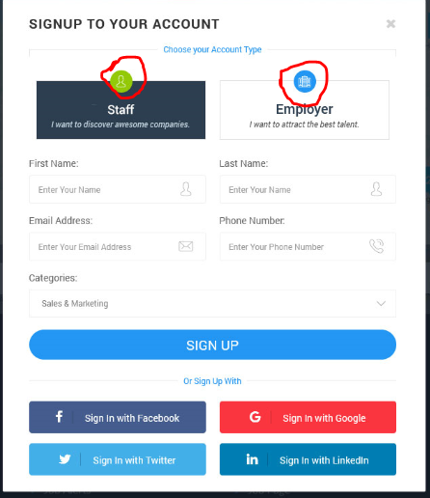

**--------------------------------------------------------------------------------------------------------------------------**

**Sign in page changes and reivew**

**Please change the icon colours as descibed above.**

**Please center the words in the middle of the page.**

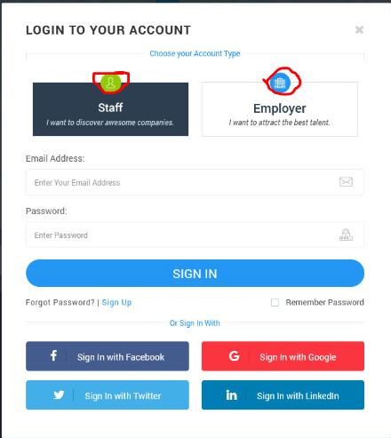

**------------------------------------------------------------------------------------------------------------------------**

**User profile page changes**

Please change “Basic info” to “Personal info”

Please change “ address” to current location (could we have on here the ability to send regulare emails or text prompts

For the user to update their location or select google located if they were happy with that.

Please remove work expertise, and considered locations and avalibility to work and about me. (all of these needs to go on a page which has their personal

profile) see after this. **DONE**

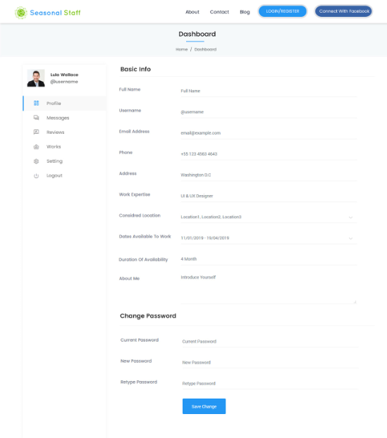**o**

**I think the page you have created on the Employees side is staff details can you please addapt the two.**

**This page will be similar to the Job profile / create a job page(so I will use that as a basis )**



Please can you create a blue button to “ Send them a message now”

Also when the employee does their profile they can choose if they want to received messages from employers

When and employer pushes “send them a message now” they can attach a job profile they have or just send

Them a message to say the are intersted, which will show up in their message box but they also get an email and or

Txt notification.

Also if a person or Business has not registered at this time, they would not be able to “send them a message” it would

Force them to the registration page.

Please ensure no contact details are visable to non registered viewers.

If they are registered all the contact details will apear for the Registered user.

When they are creating their profile please use the following

Please change the following “List a Job” would show “create a profile”,

“ Job Title” would be username for both registered and non registered users.

Then list in this order

Username

List current location

Potenital start date (this would be a calendar they can select on or can type the date in)

Potential End date (This would be a calendar they can select on or can type the date in) (this would then calculate the duration of job.)

Level of fitness. (this would show a drop down selection where the employer could choose the following “below average, average, above average”

Description of Skills and experience – This would be an area that they can put in details about the job (limit to 500 Characters )

Key skills and attributes – this section would prompt the employer to list skills and attributes (then add another Skill or attribute) so that they presented as

A list of bullet points. Add to a maximum of 15 skills and attributes (each box able to be free typed in to a maximum of 30 characters

Please create the following buttons “ post your profile” “review your profile” This would show what the profile would like like if it was posted”

And the other button would be “edit your profile” This would allow the employer to Edit or remove the add.

Please add an I accept our terms and conditions and privacy policy.

Select package- We would like to keep this option to add this later to boost personal profiles, or promote to certain audiences. (Please can you remove for the meantime

, but it is Some thing we would like to implement later)

**---------------------------------------------------------------------------------------------------------------------------------------------**

**Employer manage candidate page changes**

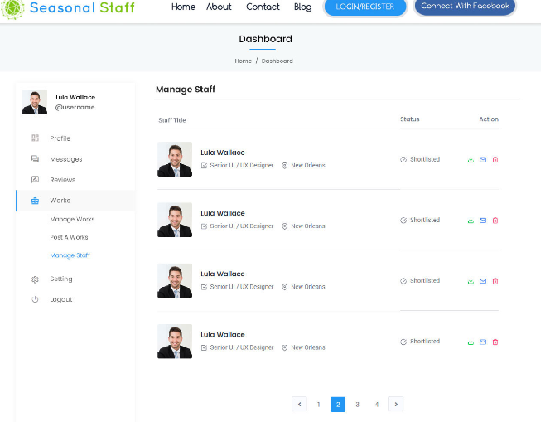

As per previous changes can the heading of the Dashboard be changed to “Employer Dashboard”

Could a large “ Blue button” be placed on the right hand side along from the employer dashboard to say “ Search for Staff”

Please repeat the same button to Display Below the “ log out on the Employer Dashboard”

I am wanting it to be easy and obvious for people to be able to find out where to go to search for staff.

If they press the “Search for Staff” button it would take them straight to the main page to search.

Can you change “Works” to “Manage Employment.”

When the Employer is in their dashboard, in the Manage Staff or any page can it clearly be shown where they are at.

Eg use a darker Grey behind the Works and Manager Staff as well as the blue colour.Can you please ensure that this is the

Same for all Dashboard pages.

Can you also indicated that under each Tab eg “Manage Employement” there is an indication that there is a drop down level

Under each heading.

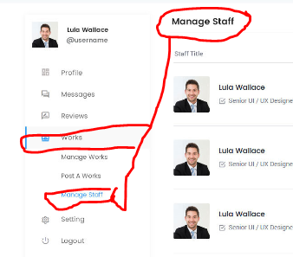

**Under action these symbols need to be bigger, I am assuming they are down load, email and delete.**

**Can I please have the following.**

**Keep the Delete Button, just make it bigger**

**Keep send a message button, Make it bigger**

**Add in a “Start a Chat button.” Can represent this by a chat bubble.**

**Have it that they can click on the persons user name or body of ad and it will take you to their profile.**

**Have some way to indicated that a chat has happened with that person. Eg bubble is darker colour**

**When was the last contact.(if a date could be put in here that would be great)**

**Have three status, Applied, Shortlisted and Unsuccessful.**

**Is it also possible to show if an email or chat has been read.**

**One each of their profiles….. (show their name or username, Current location and last online.)**

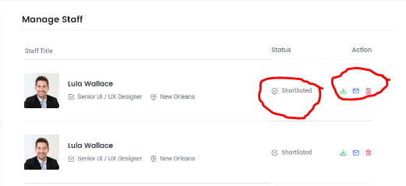

**-----------------------------------------------------------------------------------------------------------------------------------------**

**Manager works page changes.**

Please can the name of this page be changed From “Manage works” to “Manage Employment pipeline.”

On the list of the left hand side can the word “works” be replaced with “Manage Employment"

Can “works title” be changed to “Job Title”. … Can the Status be shifted so it is the first thing that is see in the columns?

Can you change “deadline” to the “Date Listed” Have “Applications” be moved to where “status” was.

Can there be 4 actions. View, Edit, Pause and delete.

“View” would take you to where you could see all the people who have made contact or applied.

“Edit” would take you to where you can edit the job.

“Pause” would allow you to put the job advert on hold and hide the advert. The employer would be able to go back to the advert and

Either “edit” or “make active again”

“Delete” would be deleting the advert.

Please can you make the Icons bigger? (I would also be happy if words were used instead)

Could this page be able to be filtered by “status” and “date listed”

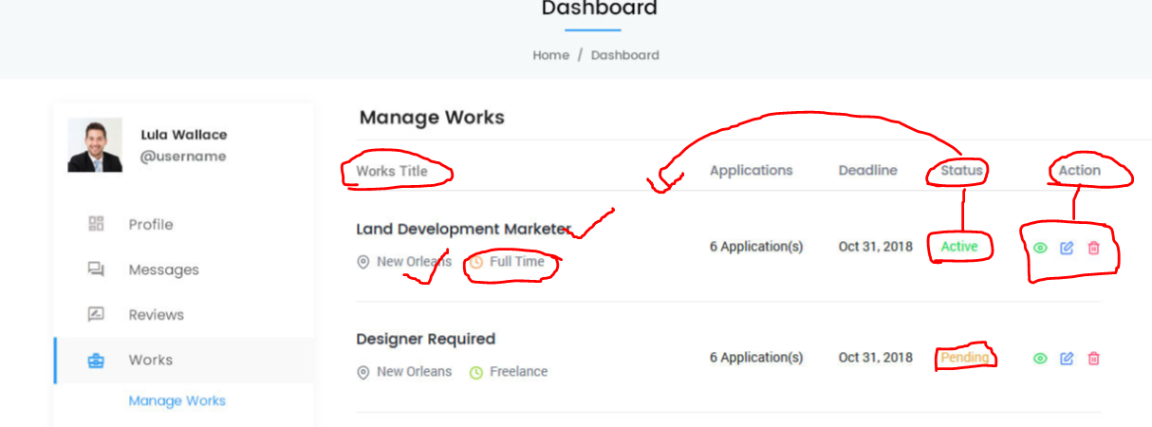

**-----------------------------------------------------------------------------------------------------------------------------------**

**Employer and Employee Message page changes.**

The employer could contact the Staff member either directly from there profile and it would then show up in here or from the Manager Staff page, or if a Staff member was

To contact an employer it would also show up here.

This would show a record what messages have been read and when they were sent. Prefer a “date and time on it please”

Please can you ensure that it is easy to see if a message has not been read? You would also be able to see how many messages you had waiting

E.g. on the left hand panel it would show 2 messages in the message box.

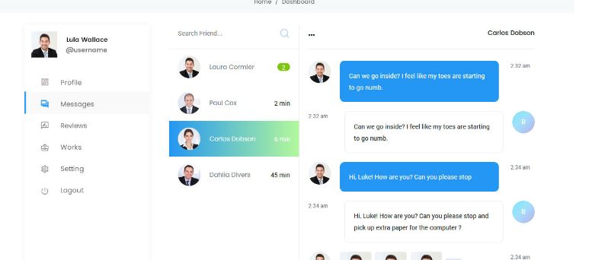

**-----------------------------------------------------------------------------------------------------------------------------------**

**Employer review page Changes**

This is something I would really like in the web site but I think it is important to get this part right. I would like the ability to introduce this

at a later date after we have got the fundamentals working. **(Please do not work on this page for the time being)**

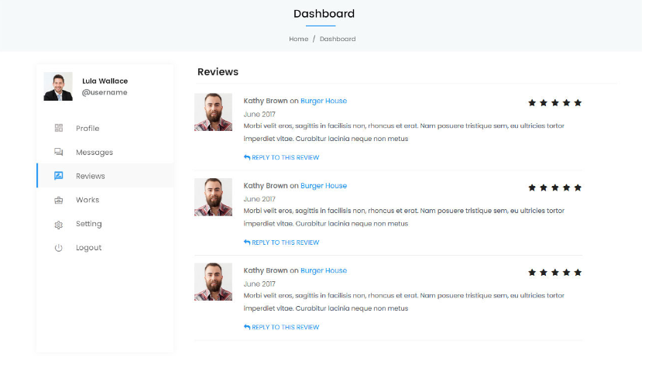

**--------------------------------------------------------------------------------------------------------------------------------**

**About us Page changes**

Please change “about seasonal Job Portal” To “About Seasonal Staff NZ”

**We are a website that only focus on Seasonal and Short term employment jobs.**

**We have created an online platform to make it easier for Seasonal workers and**

**Seasonal Business to connect. We have all heard that “We don’t have enough**

**Seasonal workers”. Well Seasonal Staff NZ is not just another “Jobs board”.**

**Our website has been designed with new way of thinking… it’s been designed**

**For the Seasonal workers by Seasonal workers.**

**Then we use innovative methods to target the niche market of workers that are**

**Prepared to do seasonal or short term employment. This benefits seasonal Business’s**

**By providing a platform where filling staff vacancies is Quick, easy and cost effective.**

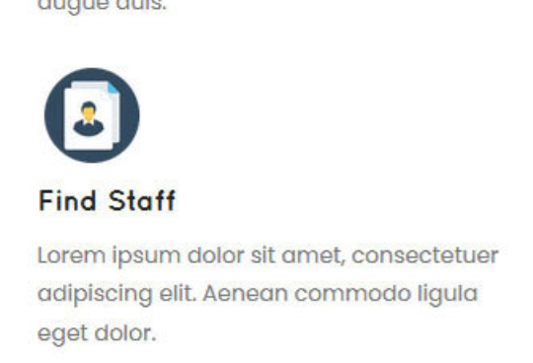

Could the logos match the colour for staff (Blue) and colour for work. (Green)

Under “Find Staff” can you put the following?

Easily find staff to fill your short term and seasonal staffing vacancies. Forecast,

Plan and advertise the whole year’s vacancies in advance, Search for people who might be

Close by who can fill your vacancy now. Know that you are connected to motivated people

Who want to do seasonal work, giving you certainty.

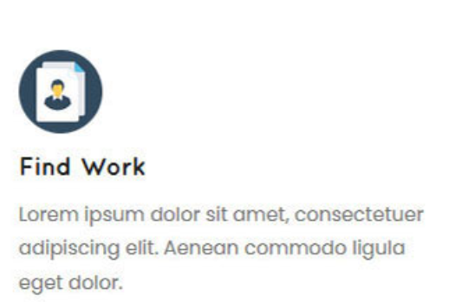

Under “Find Work” can you put the following.

Find Short term and seasonal work by location and month, Plan your working

Holiday or short term work, giving you certainty of your ability to earn money.

Easily see what other benefits are available …like accommodation, power, water

And Wi-Fi or other options like finding a pet friendly work place. Connect with a

Community of likeminded people.

Please remove the below from the website

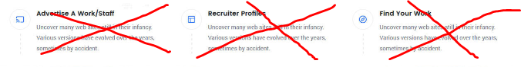

Please can you change “Your dream work are waiting” can you please change this to

“Have you joined the Seasonal Staff movement”

Remove the text “over 1 million interactions, 50,000 success stories, make yours now”

Change the two buttons “Search works and apply works now” to “Join Now”



Please change to the following 3 plans.

**Where Basic is replace with “Looking for work”**

$49.00 per year (annual subscription)

Where 03 listing is please replace with “Search by Location” (Use and interactive map to search for jobs by location)

Where 30 day viability is replace with “Search By month” (Plan your work by searching for the work in advance)

Where 100 day support pack is replace with “Search by facilities” ( Search for jobs by what facilities they offer)

Where “advance” is please replace with “Single location business”

$499.00 +GST per year.

Where” 05 listings” is Please replace with “Unlimited job listing” (Pay one flat price for unlimited job listings for the year)

Where “ 50 Day visibility” is replace with “Plan ahead” (Plan and fill staff vacancies in advance reducing your HR & Admin costs)

Where “1000 support pack” is replace with “Target audience” (Make contact with people who want to do seasonal or short term work)

Where “ultimate” is please replace with “Multiple location business”

$499 + GST* (make the note), (*$499 for the first business location then $199 + GST for each additional business location)

Where” 20 listings” is please replace with “Unlimited job listing” (Pay one flat price for each business location for unlimited job listings for the year)

Where “100 Day visibility” is replace with “Plan ahead” (Plan and fill staff vacancies in advance reducing your HR & Admin costs)

Where “150 support pack” is replace with “Target audience” (Make contact with people who want to do seasonal or short term work)

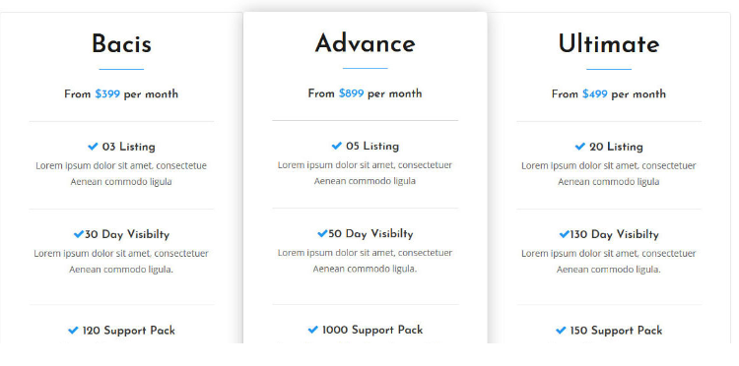

**---------------------------------------------------------------------------------------------------------------------------------**

**Contact us page changes**

Under “contact us” can you put the following.

Please feel free to contact us about Advertising, Business opportunities, general matters or to offer a suggestion.

Where the subject line is could you please have some pre written topics? (As below)

Advertising opportunity

Business opportunity

General Matters

Offer a suggestions

Other.

Keep the send message button but remove the make a suggestion button.

(Is it possible to put the “make a suggestion button” on every page. This would encourage people to make improvements

To the website and service. ) if people clicked on this button it would automatically take them to this page with “Make a

Suggestion” as the heading of the email already typed).

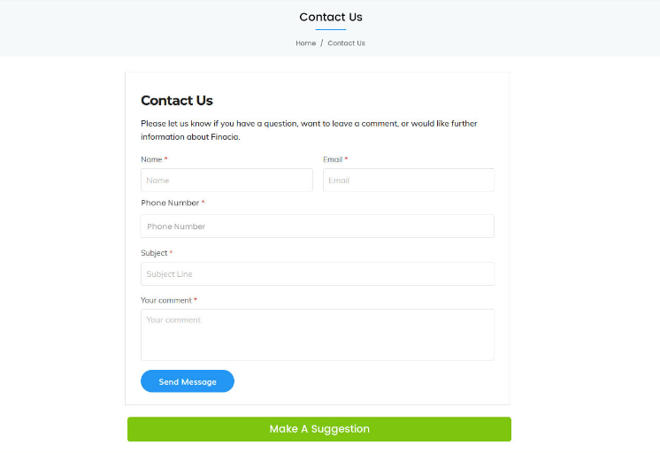

**--------------------------------------------------------------------------------------------------------------------------------**

**Pricing page changes**

Our pricing page changes.

Please change “our pricing” to “Pricing”….

Please use the three pricing strategies as listed above on the “About us” page

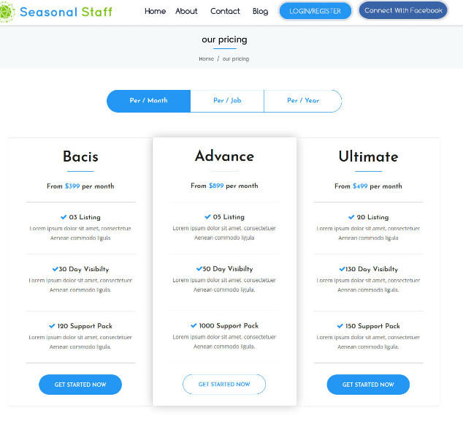

Please remove the below from the pricing page

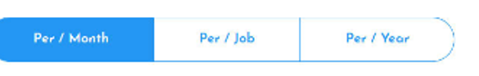

**-----------------------------------------------------------------------------------------------------------------------------------**

**User applied jobs page changes**

As per the Employer Dashboard changes can the heading of the Dashboard be changed to “Employee Dashboard”

Could a large “ Green button” be placed on the right hand side along from the employee dashboard to say “ Search for Work”

Please repeat the same button to Display Below the “ log out on the Employee Dashboard”

I am wanting it to be easy and obvious for people to be able to find out where to go to search for work.

If they press the “Search for Work” button it would take them straight to the main page to search.

Can you change “Works” to “Manage Jobs”

When the Employee is in their dashboard, or any page can it clearly be shown where they are at.

Eg use a darker grey behind the Words. Can you please ensure that this is the Same for all Dashboard pages.

Can you also indicated that under each Tab eg “Manage Employement” there is an indication that there is a drop down level

Under each heading.

Can “works” be changed to “manage Employment”

Can you change “Work applied” to “Jobs pipeline.”

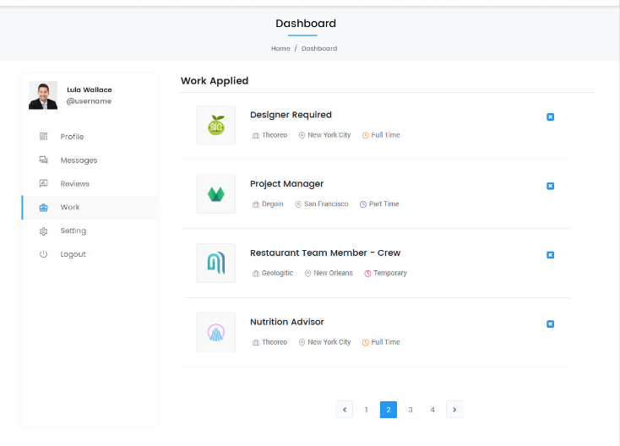

On each job that has been contacted or applied for can they show the following.

Name of Job, Location of Job, Start date of Job, Date of last contact.

Please can you also make a Status? This would show as “Not yet completed” “Sent” “Withdrawn” “Decline”

“Not yet completed” would be if they have clicked on “send CV…” or “Yes I’m interested” and the application

Or communication has not be completed.

“Sent” would be if they have completed “send CV” or “Yes I’m interested” and a message has gone to the employer.

“Withdraw” would be if the Staff member decides to withdraw their application. “This would generate an automatic

Email and chat message to let the employer know they are withdrawing their application.

“Decline” would send an automatic email or chat to let the employer know they have “Declined” their offer”

There also needs to be an option for the employee to send another message to the employer of that job.

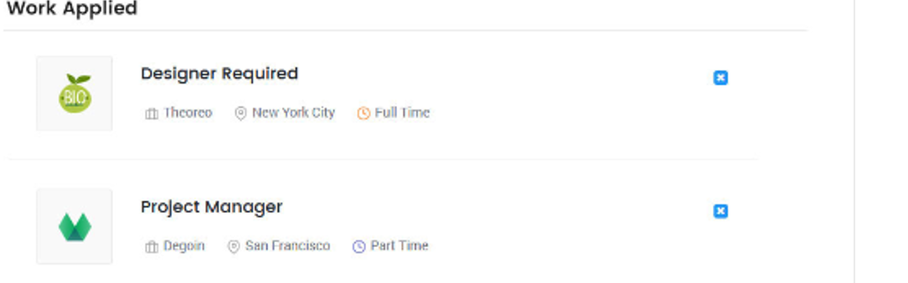

-----------------------------------------------------------------------------------------------------------

Blog page changes.

I am happy with the layout of the Blog page. This needs to be a page that we have the ability to

Update and add to as admins of the page. (This also needs to be able to shared and interact with Facebook

And Instagram”

Also can this page have pictures and video’s uploaded to it?